1. Displays session expired in repeated login attempts:

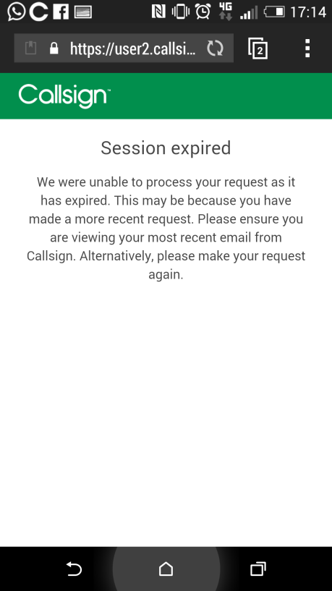

2. Callsign App stopped during the access:

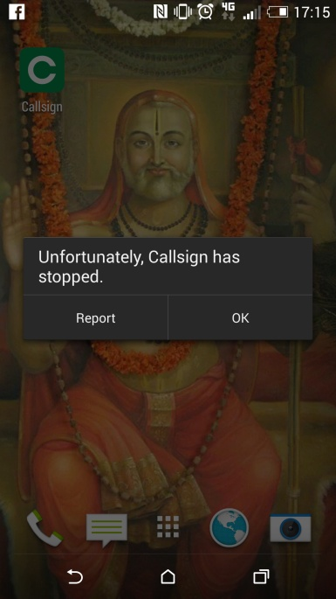

3. While reactivating account, message displayed like poor connectivity and did not send the message:

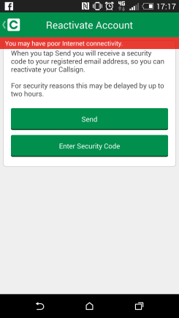

4. Unable to register in callsign due to the same name has registered already:

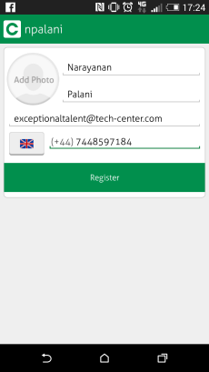

5. Mobile hangs during sms button is pressed:

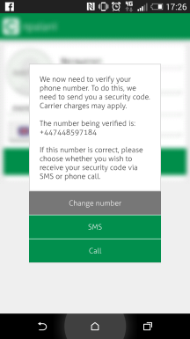

6. npalani is used to register but this is not recognised:

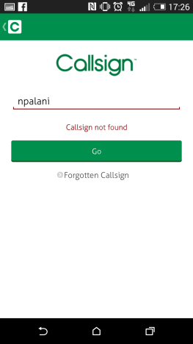

7. After entering the callsign id, Go button is still disabled:

